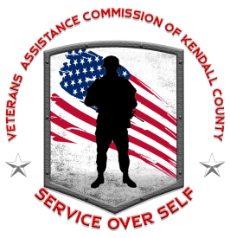
VETERANS ASSISTANCE COMMISSION OF KENDALL COUNTY
“Service Over Self”
811 West John Street, Yorkville, IL 60560
Phone: (630) 553-8357 Fax: (630) 553-0003
Email: clockman@co.kendall.il.us Website: www.kendallvets.org

2022 SCHOLARSHIP ANNOUNCEMENT

The Veterans Assistance Commission of Kendall County (VACKC) is now accepting applications for the 2021 Veteran Memorial Scholarship: In Honor of Gene A. White, Arnold J. Bitterman, Bradley “Steve” Barrett and Jim “Flash” Likeness. This year, three scholarships will be available in the amount of $2,000.00 each and one scholarship in the amount of $3,000.00.

Applicants must meet the scholarship’s eligibility criteria as outlined in the scholarship policy. All completed applications and supporting documentation must be received no later than the close of business on March 31, 2022.

Applications and supporting documentation can be submitted via e-mail to kclevenger@co.kendall.il.us, via fax to (630) 553-0003, or dropped-off in person. If dropping-off in-person, arrangements must be made beforehand by contacting the VACKC.

Any questions or concerns regarding the application process should be directed to the Assistant Superintendent Karylin Clevenger. Thank you for your interest and participation.

Respectfully,
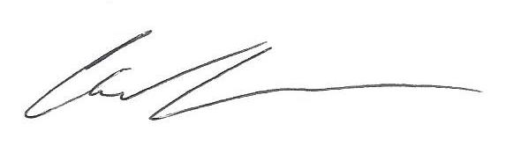
Chad Lockman
Superintendent

